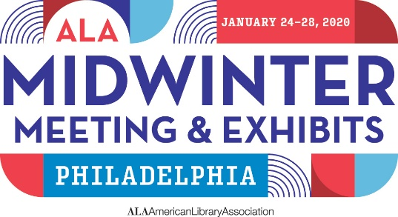

Making your case TO attenD
Making the case for time off and support for travel and expenses to attend a conference requires a solid understanding of the potential benefits to your institution, supervisor, and colleagues. And you need to be able to communicate those benefits clearly—especially in times of tight budgets and reduced staff. Use this sample memo to help make your case.

Sample Memo
To: Your Boss
From: You
Re: Attendance at the 2020 ALA Midwinter Meeting & Exhibits
Date: As early as possible
The 2020 ALA Midwinter Meeting & Exhibits takes place in Philadelphia, PA on January 24-28, 2020. This event is largely focused on the librarian, with emphasis on peer-to-peer sessions on trends and innovation. The Symposium on the Future of Libraries will focus on the future, with three days exploring academic, public, school, and special libraries, and plenary sessions with civic, education, and social innovators creating what’s next for cities, campuses, and communities.
Connections are boundless and will offer long-term professional benefits, including sharing ideas and best practices throughout the field.
If I am supported to attend the 2020 ALA Midwinter Meeting, here are some ways in which I would ensure that the investment pays dividends for the library, and how I would make the most of the opportunity for professional development.
[If you are a committee member or participate in ALA activities, list related meetings you plan to attend and why, how your participation can help the profession, your library, and your own professional development.]
[The following are suggested ways to talk about how you would spend your time.]
I would attend the following programs, among others:
- List 4-5 programs related to your work and why they will help you do your job better
- Program 2
- Program 3
- Program 4
I would plan on spending a minimum of xx hours in the exhibit hall. I would meet with our current vendors as appropriate, to build our personal relationships. I would focus on vendors and new product demonstrations in the following areas, looking for cost-effective innovations and new products, doing comparison shopping, and positioning us for negotiating best terms:
- Current vendor(s)—list
- Vendors in a specific area/field
- Vendors by name
- New products I’ve read or heard about and wish to see demos of etc.
The networking at ALA conferences is outstanding. I would represent our library as forward-thinking and dynamic in my interactions with people I meet, and would seek to connect with people whose ideas and specializations seem most likely to benefit our library as well as contribute to my professional development and education, making me increasingly effective in my job. I would network with people I meet while attending sessions, discussions, programs, and events, and would also plan to make the most of specific networking opportunities.
After I return, I would take the following steps to ensure that what I learn benefits the library:
- Implement at least one new idea that makes us more efficient and/or effective.
- Share notes on sessions
- Share my list of action items and general ideas
- Provide a written report
I would need xx days away from work to attend. The costs are as follows:
[import from budget worksheet]
And making the decision as soon as possible offers the potential discount savings. Thank you for your consideration.
[Name]

